ETV on Short Film Appreciation (II): Snap Chat
Learning Activity Sheets (for English Language Students)

This set of materials is designed to support the learning and teaching of the English Language curriculum at the secondary level. The aim is to promote students’ viewing and writing skills, and enhance their critical thinking capability.

This set of materials contains the following:
- Student’s copy
- Teacher’s notes (with suggested answers)
- A short film titled “Snap Chat”

They are intended for use by English Language teachers to provide guidance to secondary students on how to appreciate films and write a film review. The materials can be used as a learning task in class to introduce the different elements of a film and the text structure and language of a film review, or as supplementary materials to extend students’ learning beyond the classroom and promote self-learning.

Writing a Film Review: Snap Chat
Learning Activity 1: General Information of the Film
Watch the short film “Snap Chat” and complete the following table. You may need to watch it more than once.
Title | Snap Chat
Year of Release | 2018
Genre | Comedy
Director | Annie Yau
Length | 6:28 min
Cast / Character | Jamie Putnam as Jacob  Bryony Morgan as Brian  Justin Wong as Jonathan | Yu Kakinoki as Yolanda  Niamh Tair as Mia

Learning Activity 2: Understanding and Summarising the Plot
Part A: Number the pictures in the order of appearance and answer the questions that follow.
 | 1 |  | 6
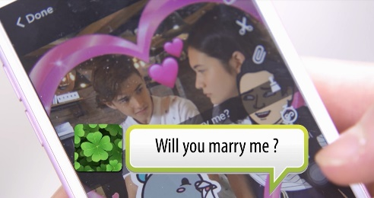 | 5 |  | 3
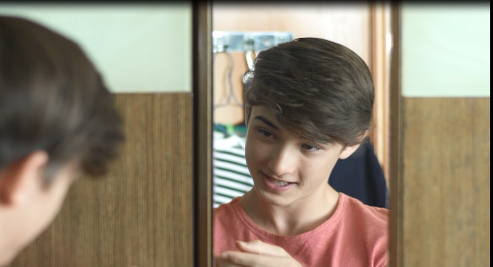 | 4 | 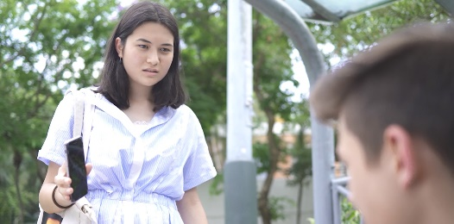 | 7
 | 2 | 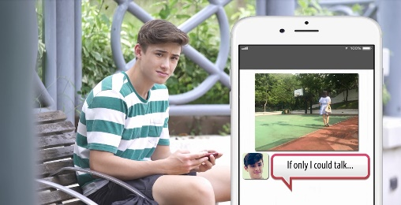 | 8

1. | Where is the film set?
 | The film is set in contemporary Hong Kong, revolving around the everyday
 | lives of a few teenagers.
2. | Who are the main characters?
 | The main characters are Jacob who likes taking pictures and uploading them
 | to a social media platform, and Yolanda whom Jacob has a crush on.
3. | What happens in the opening of the film?
 | The film starts with Jacob’s being woken up by the alarm on the smartphone
 | and his obsessive use of the smartphone.
4. | How is the story told in the film?
 | The events in the story are presented in chronological order.

Part B: Analyse the plot using the four key stages of the plot structure.
Stage 1 The Beginning
Where does the story begin? What characters are introduced? How are they introduced?
The story starts with an ordinary day of a teenager, Jacob. He is portrayed
as a Snapchat addict. He shares with his friends every single detail in his life
through Snapchat, including his having a crush on a girl, Yolanda, whom he
sees on a ferry.
Stage 2 The Conflict
What are the events that lead to the main problem of the story?
Jacob bumps into Yolanda at a café. Knowing his crush on Yolanda, his friends
take a picture of them secretly. They add frames and stickers to the picture,
make up a romantic story between them and share it with their friends.
Unaware of what is going on, Jacob is dwelling on his fantasy of asking
Yolanda out.
Stage 3 The Climax
What is the main problem of the story? What is the most intense moment of the story?
Yolanda sees the picture on her friend’s phone and gets furious. She runs into
Jacob and confronts him with the picture, which he knows nothing about.
Jacob is at a loss for words.
Stage 4 The Resolution
How does the conflict end? What happens to the characters at the end?
Jacob can do nothing but let Yolanda leave his sight. He shares through
Snapchat a picture of her with the caption “If only I could talk”.

Learning Activity 3: Describing a Scene
Describe the following scene. Use the present tenses and participles, if applicable. You may describe the characters’ facial expressions and body language.

Sitting around the same table, Jacob and his friends are merrily chatting with
one another on their smartphones. They focus all their attention on their
phones and ignore the physical presence of one another as if they were
strangers.

Select a scene in the short film which impresses you most and describe it.
Scene _______________ (indicate the time)

Learning Activity 4: Analysing Filmic Elements
Watch the following excerpts from the short film and describe the editing, music and sound effects used, and explain their functions. Some examples are provided for you.
Duration | Filmic Elements | Functions
0:29 – 0:55 | Music and sounds:  fast, rhythmic, funky, camera shutter sounds, key pad clicks | to complement Jacob’s brisk daily routines
0:28 – 0:55 | Editing:  rapid cuts to show the actions in a disjointed way | - to mimic the motion of a camera shutter  - to suggest frequent interruptions and distractions arising from the use of smartphone
1:47 – 2:08 | Music:  slow, heartwarming | to create a sense of tenderness and show Jacob’s adoration for Yolanda
2:10 – 2:25 | Sounds:  no music, key pad clicks, giggling | to emphasise the absence of verbal communication among a group of friends sitting around the same table
3:10 – 3:52 | Editing:  alternating different scenes that are happening at the same time | to intensify the conflict and complicate the plot as the photo travels around the Snapchat group and becomes increasingly distorted while Jacob is dwelling on his fantasy of dating Yolanda
4:41 – 4:45 | Music:  light-hearted, comical | to create a sense of funniness and how Jacob is ridiculed

Learning Activity 5: Identifying Themes and Messages
Identify the theme of the short film “Snap Chat” by writing down (an) appropriate theme word(s) and a theme statement.

Theme word(s) |  | Theme statement
obsession / social media / relationship / virtual world |  | Obsession with social media is harmful to social life and
 |  | relationships. / Overuse of social media hampers true
 |  | engagement with others. / We may lose touch with the
 |  | actual world if we indulge in the virtual world.

Learning Activity 6: Writing a Film Review
Write a film review on the short film “Snap Chat”.
Snap Chat ( |  |  | 2018 | )
Director: |  | Annie Yau
 | 6:28 Min / Comedy
 | “Snap Chat” is a story about how a misunderstanding caused by inappropriate
 | use of social media platforms affects relationships in real life. The film is
 | directed by Annie Yau, featuring Jamie Putnam as Jacob and Yu Kakinoki as
 | Yolanda. The short film is highly relatable to many Hong Kong people,
 | especially teenagers, showing us how pervasive and damaging the impacts of
 | technology can be.
 | The story starts with an ordinary day of the main character, Jacob, who is
 | portrayed as a Snapchat addict. He shares with his friends every single episode
 | of his life through Snapchat. The story gets complicated when a picture of Jacob
 | and Yolanda, secretly taken by his friend, is distorted and circulated among
 | his friends. The fake news about their romantic relationship goes viral online.
 | Can Jacob stop the rumour from spreading in the end?
 | The editing of “Snap Chat” earns my praise. It is more sophisticated and
 | effective than that of “My Grandmother”, the previous work of Yau. In one of
 | the episodes, Yau successfully creates a contrast between Jacob’s absorption
 | in his own romantic fantasy and the trick his friends are playing on him by
 | weaving different scenes which happen at the same time but in different
 | places together. While the audience knows that something bad is going to
 | happen with the touched-up photo, Jacob is completely in the dark, which
 | creates tension and irony in the film.
 | Music and sound effects are equally commendable. The fast and brisk music,
 | together with the sounds of key pad clicks and rapid cuts, in the opening scene
 | reflects that teenagers’ lives revolve around their smartphones. The acting of
 | the characters is realistic and convincing. The performance of Jamie Putnam is
 | remarkable and he successfully brings the character of a social cripple to life.
 | Confronted by Yolanda, he cannot explain himself but stutters, which wittily
 | echoes one of the lines in the film - “If only I could talk”.
 | The film is thought-provoking. No doubt, smartphones and social media have
 | become pervasive in life. Yet, obsession with them can be harmful to our social
 | lives and relationships. It is comical but ironic to see that Jacob and his friends
 | are chatting on their phones though they are just sitting next to one another.
 | It is also fun to see how the joke escalates but nobody can imagine how a
 | seemingly harmless joke can lead to misunderstandings and conflicts.
 | “Snap Chat” is far more than a comedy; it is a reflection of our lives, allowing
 | room for us to think about how technology affects our relationships. I give
 | the film the thumbs up and will recommend it to my friends.

